**Project Deliverable 4**

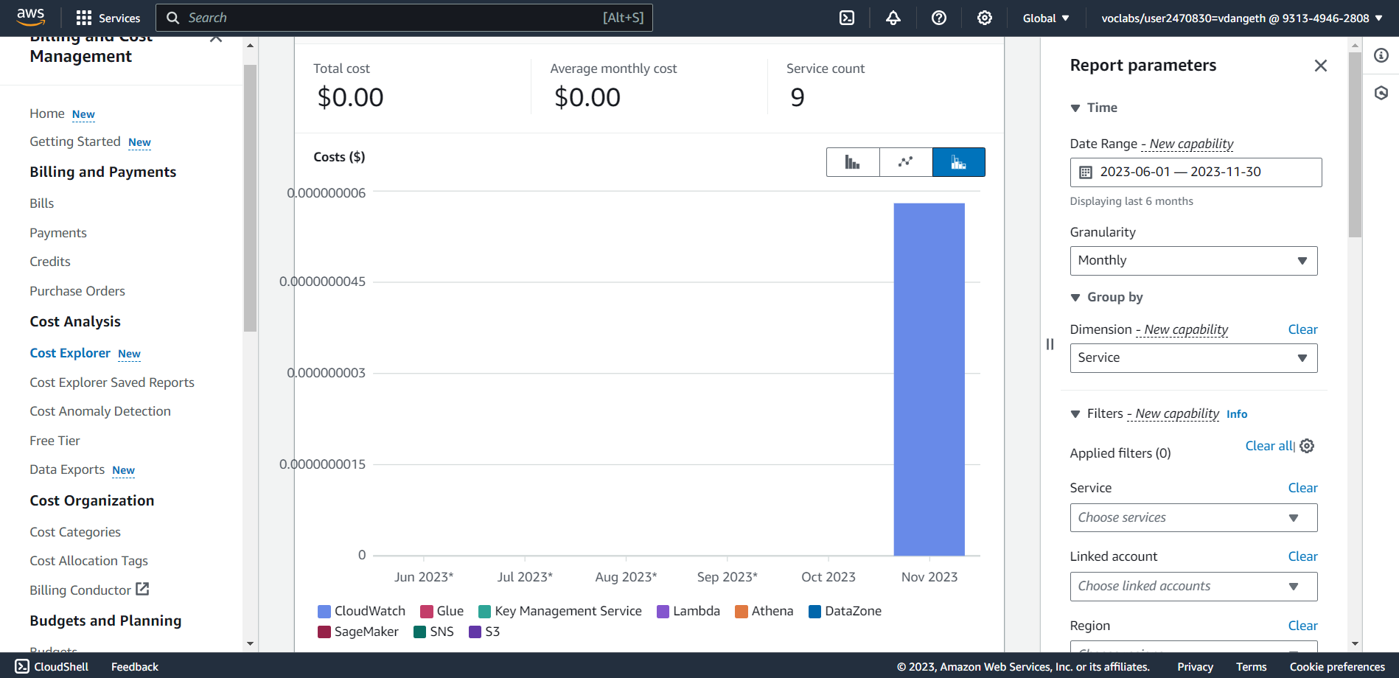

Our current AWS cost is $0.00, demonstrating efficient resource utilization within the free tier. However, we will continue to monitor my usage and implement cost optimization measures as our cloud environment evolves.

Reason for other services listed in AWS Cost Explorer report besides Athena, Glue, S3, and SageMaker:

Indirect Costs:

Although we may only be actively using Athena, Glue, S3, and SageMaker, other services might be incurring indirect costs associated with our usage. This can happen in a few ways:

* Underlying services: Some services are used implicitly by those we're explicitly using. For example, Athena relies on CloudWatch for logging and monitoring, and Glue might utilize SQS for queuing jobs.
* Resource dependencies: Our resources might depend on other services we're not directly interacting with. For instance, our SageMaker notebook instances might be running on EC2 instances, leading to EC2 costs.
* Shared resources: If using shared resources like VPCs, EBS volumes, or IAM roles, their costs might be allocated to different services using them, including those we're not actively using.